### **Capstone Project Concept Note and Implementation Plan**

### **Project Title:** Automated Malaria Parasite Detection System

**Team Members**

* [Abbas Muhammad Zakariya]
* [Edson]

#### **Concept Note**

**1. Project Overview**

This capstone project focuses on leveraging Convolutional Neural Networks (CNNs) to automate the detection of malaria parasites within thin smear microscopic images. The initiative aligns with Sustainable Development Goal 3 by aiming to enhance healthcare outcomes through rapid and precise malaria diagnosis. By addressing the inefficiencies in manual detection, the project intends to significantly impact timely treatment and improve patient outcomes in regions affected by malaria.

**2. Objectives**

* Develop a robust deep learning model for automated malaria parasite detection.
* Enhance diagnosis efficiency for healthcare professionals.
* Contribute to timely treatment and improved patient outcomes in malaria-affected regions.

**3. Background**

The project addresses the pressing need for efficient and accurate malaria parasite detection, especially in resource-limited areas. Existing literature and initiatives showcase the potential of machine learning, particularly CNNs, in automating detection processes, thereby reducing dependency on human expertise and improving accessibility to reliable diagnostics.

**4. Data Sources**

The dataset comprises 27,558 images categorized into infected and uninfected cells. Sourced from the official NIH website's malaria datasets repository, it provides a foundation for training CNN architectures for accurate classification between infected and healthy cells.

**5. Literature Review**

Existing research demonstrates the effectiveness of deep learning models in malaria parasite detection. The project builds upon this work by focusing on CNN-based methodologies for precise and automated detection.

**4. Methodology**

Utilization of CNN architectures due to their efficacy in image recognition tasks. Preprocessing techniques include standardizing image sizes, contrast enhancement, and data augmentation for model robustness and generalization.

**5. Architecture Design Diagram**

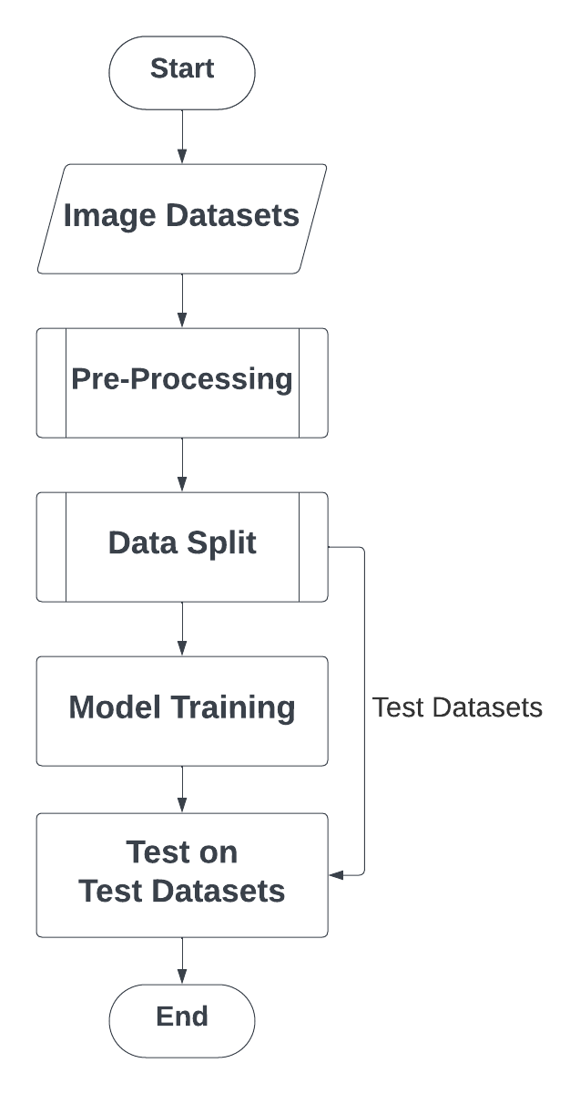

#### **Implementation Plan**

1. **Technology Stack**

* Python (programming language)
* TensorFlow, Keras (libraries)
* CNN frameworks
* Possibly Google Colab for collaborative development

**2. Timeline**

| **Phase** | **Week 1** | **Week 2** | **Week 3** | **Week 4** |
| --- | --- | --- | --- | --- |
| Data collection and preprocessing completion |  |  |  |  |
| Model development and training phase |  |  |  |  |
| Model evaluation and fine-tuning |  |  |  |  |
| Successful deployment and usability testing |  |  |  |  |

**3. Milestones**

* Data collection and preprocessing completion
* Model development and training phase
* Model evaluation and fine-tuning
* Successful deployment and usability testing

**4. Challenges and Mitigations**

* Data Quality: Implement rigorous data preprocessing techniques to handle any inconsistencies or imbalances in the dataset.
* Model Performance: Continuous evaluation and fine-tuning based on validation metrics to enhance accuracy and reduce false positives/negatives.
* Technical Constraints: Regular system checks and adaptations to handle computational limitations.

**5. Ethical Considerations**

Ethical considerations include ensuring data privacy, mitigating biases in the model predictions, and assessing the impact on the target community for fair and equitable access to healthcare solutions.